**OpenRC Differential Assembly**

Before you begin remove support and check parts for scrap plastic and remove if needed.

Tighten screws with care, the parts need to align perfectly or you will end up with a piece of blob in a matter of seconds. Be careful when tightening screws so you don´t break the parts.

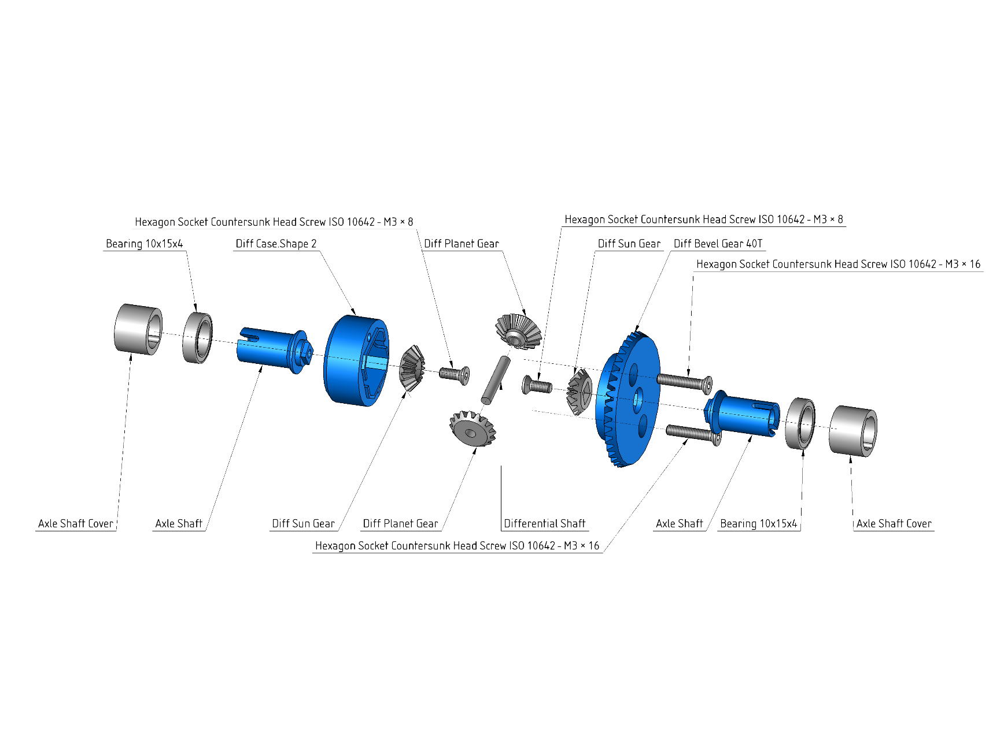When done the diff will feel like it´s a little too tight but don´t worry it will wear in!